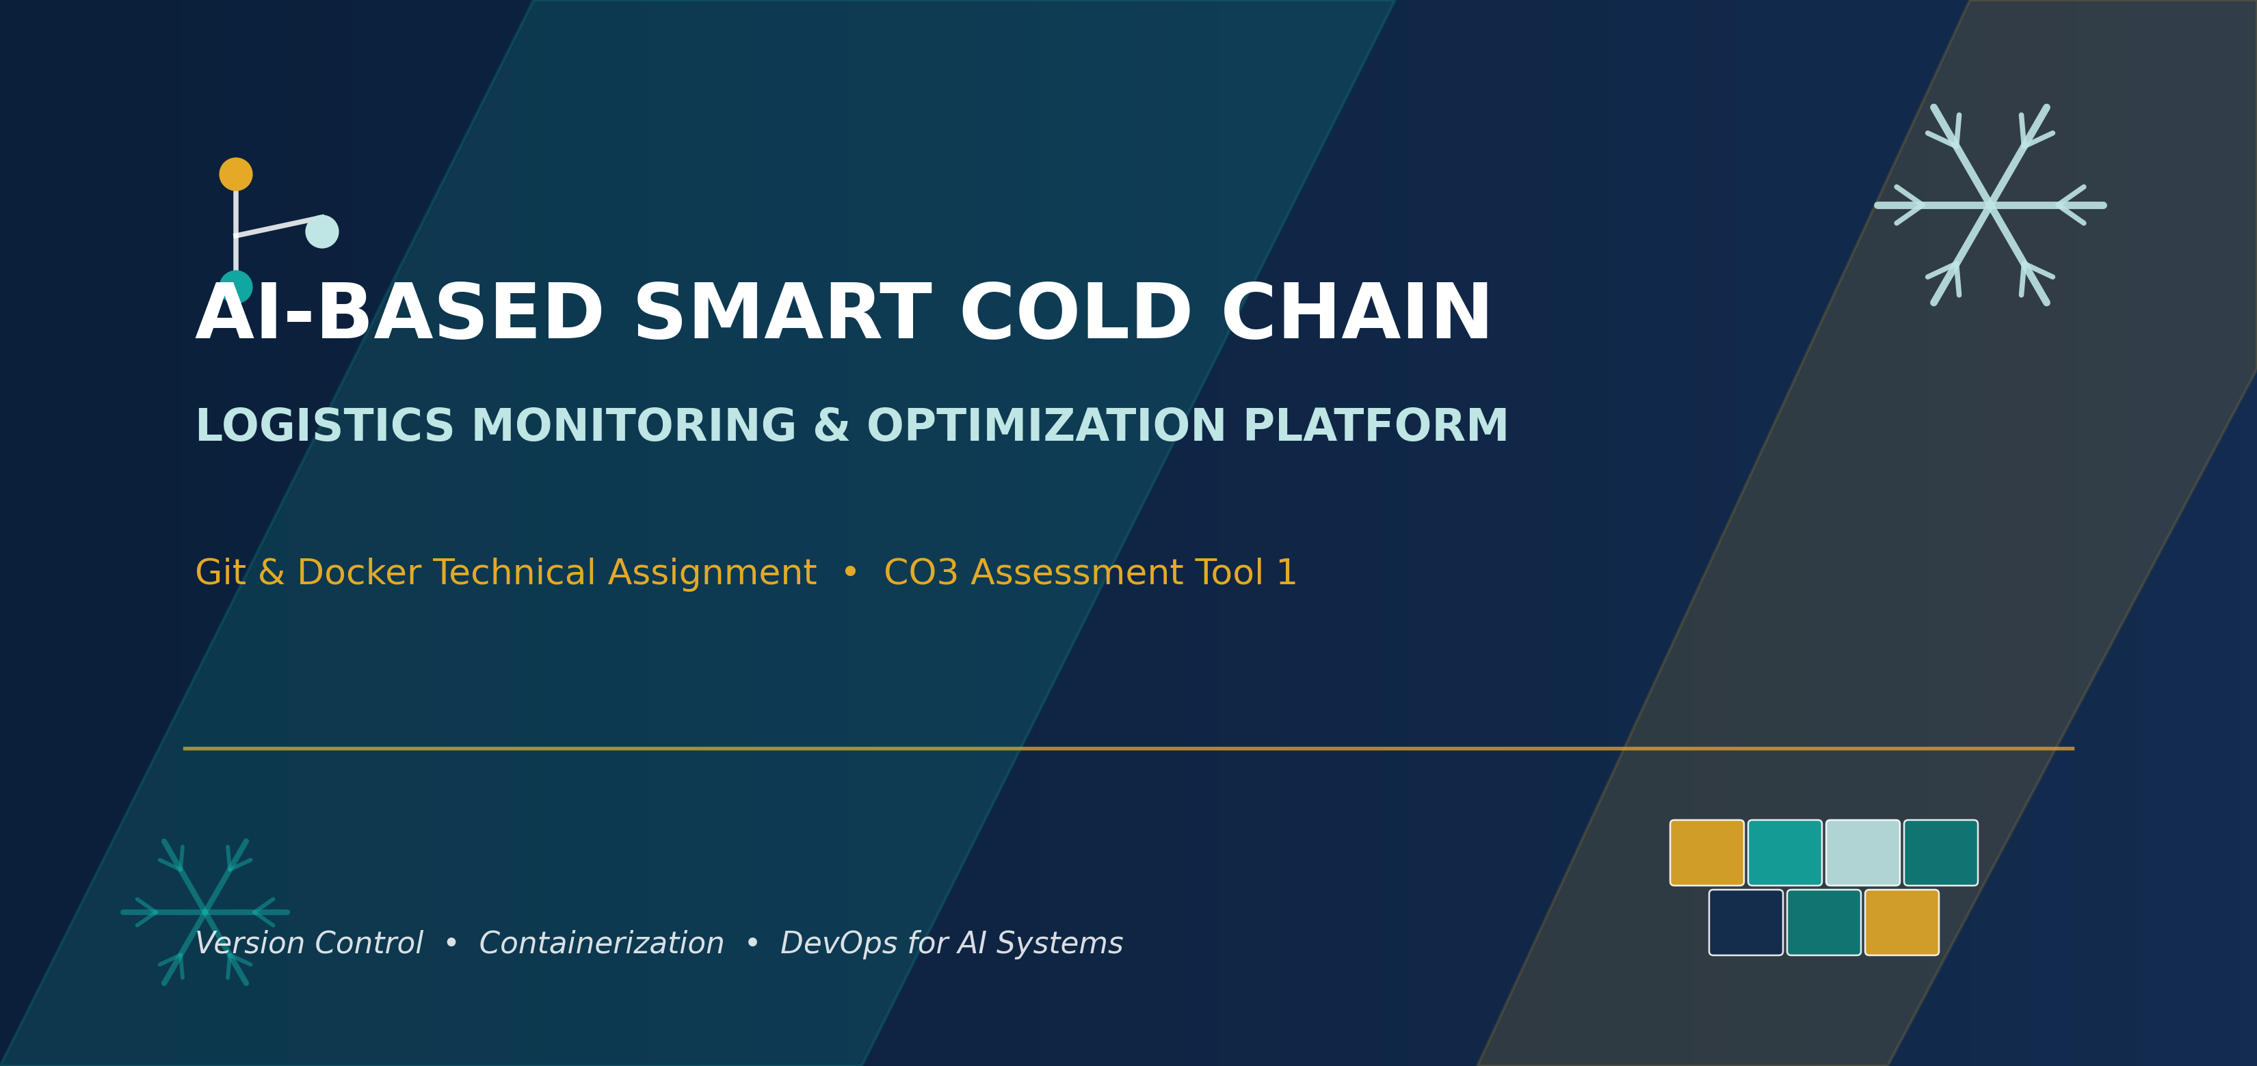

Student Name | Manisha
Register Number | 192424130
Programme | B.Tech — Artificial Intelligence & Data Science
Institution | Saveetha Institute of Medical and Technical Sciences (SIMATS Engineering)
Assessment | CO3 Assessment Tool 1 — Git & Docker Technical Assignment
Assigned Problem | 6. AI-Based Smart Cold Chain Logistics Monitoring and Optimization Platform

1. Problem Analysis
Cold chain logistics is responsible for transporting temperature-sensitive goods such as vaccines, pharmaceuticals, dairy products, seafood, and fresh produce from origin to destination without breaking the required temperature range. In the assigned scenario, existing monitoring practices are largely manual or rely on periodic checks, which means that a refrigeration failure, a delayed shipment, or a sudden temperature spike may not be detected until the damage has already occurred. The objective of this project is to design an AI-powered platform that continuously observes shipment conditions through IoT sensors, applies machine learning to anticipate equipment failure before it happens, and gives logistics teams the visibility they need to intervene in time.
Project Objectives
- Continuously monitor temperature and humidity inside refrigerated vehicles and storage units.
- Track shipment location in real time using GPS integration.
- Predict refrigeration equipment failure using historical sensor and maintenance data.
- Recommend optimized transportation routes that reduce transit time and temperature exposure.
- Generate automated alerts the moment a reading crosses a safe threshold.
- Provide analytics dashboards summarising fleet-wide logistics performance.
- Reduce spoilage-related financial loss and improve regulatory compliance.
- Improve end-to-end visibility for suppliers, carriers, and receivers.
Functional Requirements and Expected Outcomes
Functional Requirement | Description | Expected Outcome
Real-time sensor ingestion | Collect temperature, humidity and door-open events from IoT devices every few seconds. | Continuous, low-latency visibility into shipment conditions.
Predictive maintenance | Apply ML models on historical reefer-unit telemetry to flag likely failures. | Fewer in-transit breakdowns and proactive servicing.
Route optimization | Combine traffic, distance and cold-chain risk data to suggest the safest route. | Shorter exposure windows and reduced fuel/time cost.
Automated alerting | Trigger SMS/email/dashboard alerts on threshold breaches. | Faster human intervention and reduced spoilage.
Performance analytics | Aggregate KPIs such as on-time delivery and spoilage rate. | Data-driven decisions for fleet and vendor management.

2. Project Structure Design
The repository is organised as a set of independently deployable services, mirroring the microservice boundaries of the platform. This keeps the codebase easy to navigate, lets each service evolve and be containerized on its own schedule, and keeps CI/CD pipelines fast because only the changed service needs to be rebuilt.
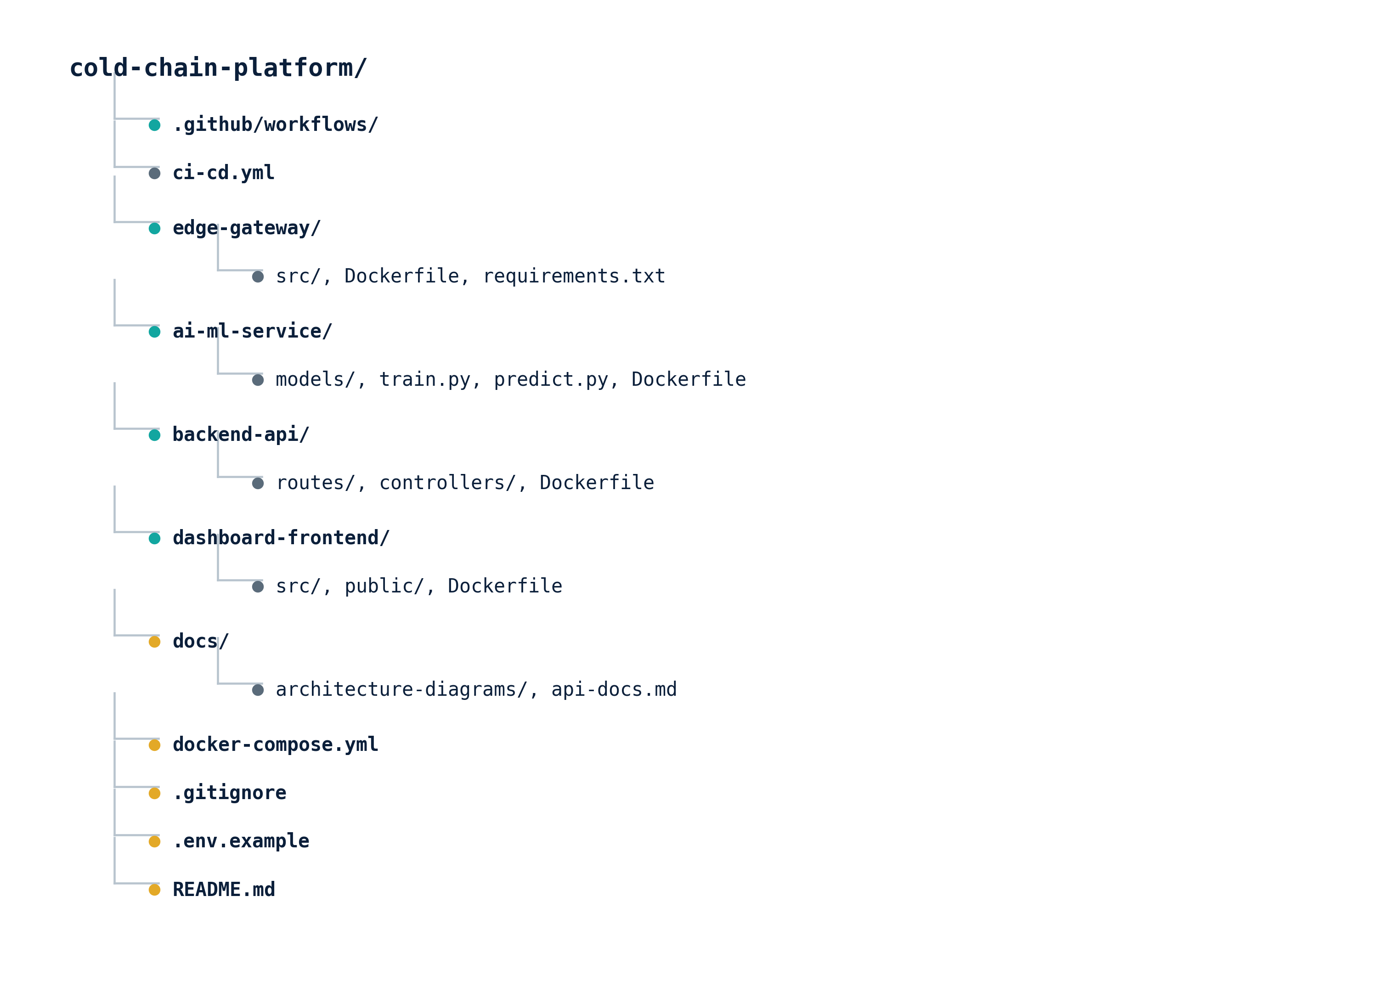
Figure 2.1 — Top-level repository folder structure
Purpose of Major Folders and Files
Path | Purpose
.github/workflows/ | Holds CI/CD pipeline definitions (ci-cd.yml) that automatically build, test and lint every push/PR.
edge-gateway/ | Lightweight service that aggregates raw IoT sensor readings and forwards them over MQTT.
ai-ml-service/ | Houses the failure-prediction and route-optimization models, along with training scripts.
backend-api/ | Core microservice exposing REST endpoints consumed by the dashboard and mobile clients.
dashboard-frontend/ | Web application that renders real-time shipment maps, alerts and analytics charts.
docs/ | Architecture diagrams, API references and onboarding notes for new contributors.
docker-compose.yml | Defines and wires together every container needed to run the full stack locally or in staging.
.gitignore | Prevents build artefacts, dependency folders, and secrets from being committed.
.env.example | Documents the environment variables each service expects, without exposing real secrets.
README.md | Entry point describing setup, architecture and how to run the project.

3. Git Repository Initialization
Every service begins its life the same way: a local Git repository is created, the essential metadata files are added, and the first commit establishes a clean baseline that the rest of the team can branch from.
Initialization Steps
$ mkdir cold-chain-platform && cd cold-chain-platform
$ git init
Initialized empty Git repository in /cold-chain-platform/.git/
$ git config user.name "Manisha"
$ git config user.email "manisha@simats.edu.in"
$ touch README.md .gitignore .env.example
$ git add .
$ git commit -m "chore: initial commit - project scaffolding"
$ git branch -M main
$ git remote add origin https://github.com/<org>/cold-chain-platform.git
$ git push -u origin main
Purpose of Essential Git Files
File / Folder | Purpose
.git/ | Hidden directory that stores the entire version history, refs, and Git configuration for the repository.
.gitignore | Lists patterns (node_modules/, __pycache__/, .env) that Git should never track, keeping the repo clean.
README.md | First document a collaborator reads; explains what the project does and how to run it.
.env.example | Template for required environment variables, committed safely without real credentials.
LICENSE | States the terms under which the code may be reused or redistributed.

4. Git Branching Strategy
Because the platform has multiple services under active development, a Gitflow-inspired branching model was chosen. It separates code that is stable and deployable (main), code that is being integrated for the next release (develop), isolated units of new work (feature/*), release stabilisation (release/*), and urgent production fixes (hotfix/*). This keeps main always deployable while giving contributors a safe space to experiment.
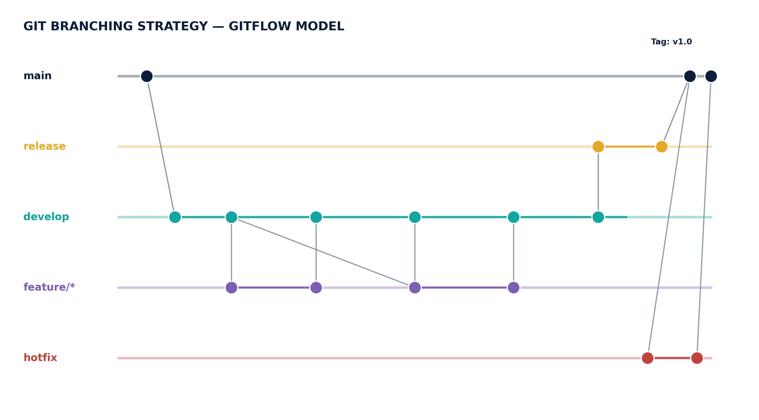
Figure 4.1 — Gitflow branching model applied to the cold chain platform
Branch Roles and Naming Convention
Branch | Purpose | Naming Example
main | Always reflects the current production-ready release. | main
develop | Integration branch where completed features are merged and tested together. | develop
feature/* | One branch per new capability; deleted after merge into develop. | feature/route-optimizer
release/* | Stabilises a develop snapshot ahead of a production release (bug fixes only). | release/v1.2.0
hotfix/* | Branches directly off main to patch a critical production issue. | hotfix/sensor-null-crash
This model suits the assigned project because the platform serves cold chains carrying regulated goods such as vaccines — an untested change reaching main is not an acceptable risk. Gitflow's explicit release and hotfix branches give the team a controlled way to patch production urgently while feature work on develop continues undisturbed.

5. Version Control Workflow
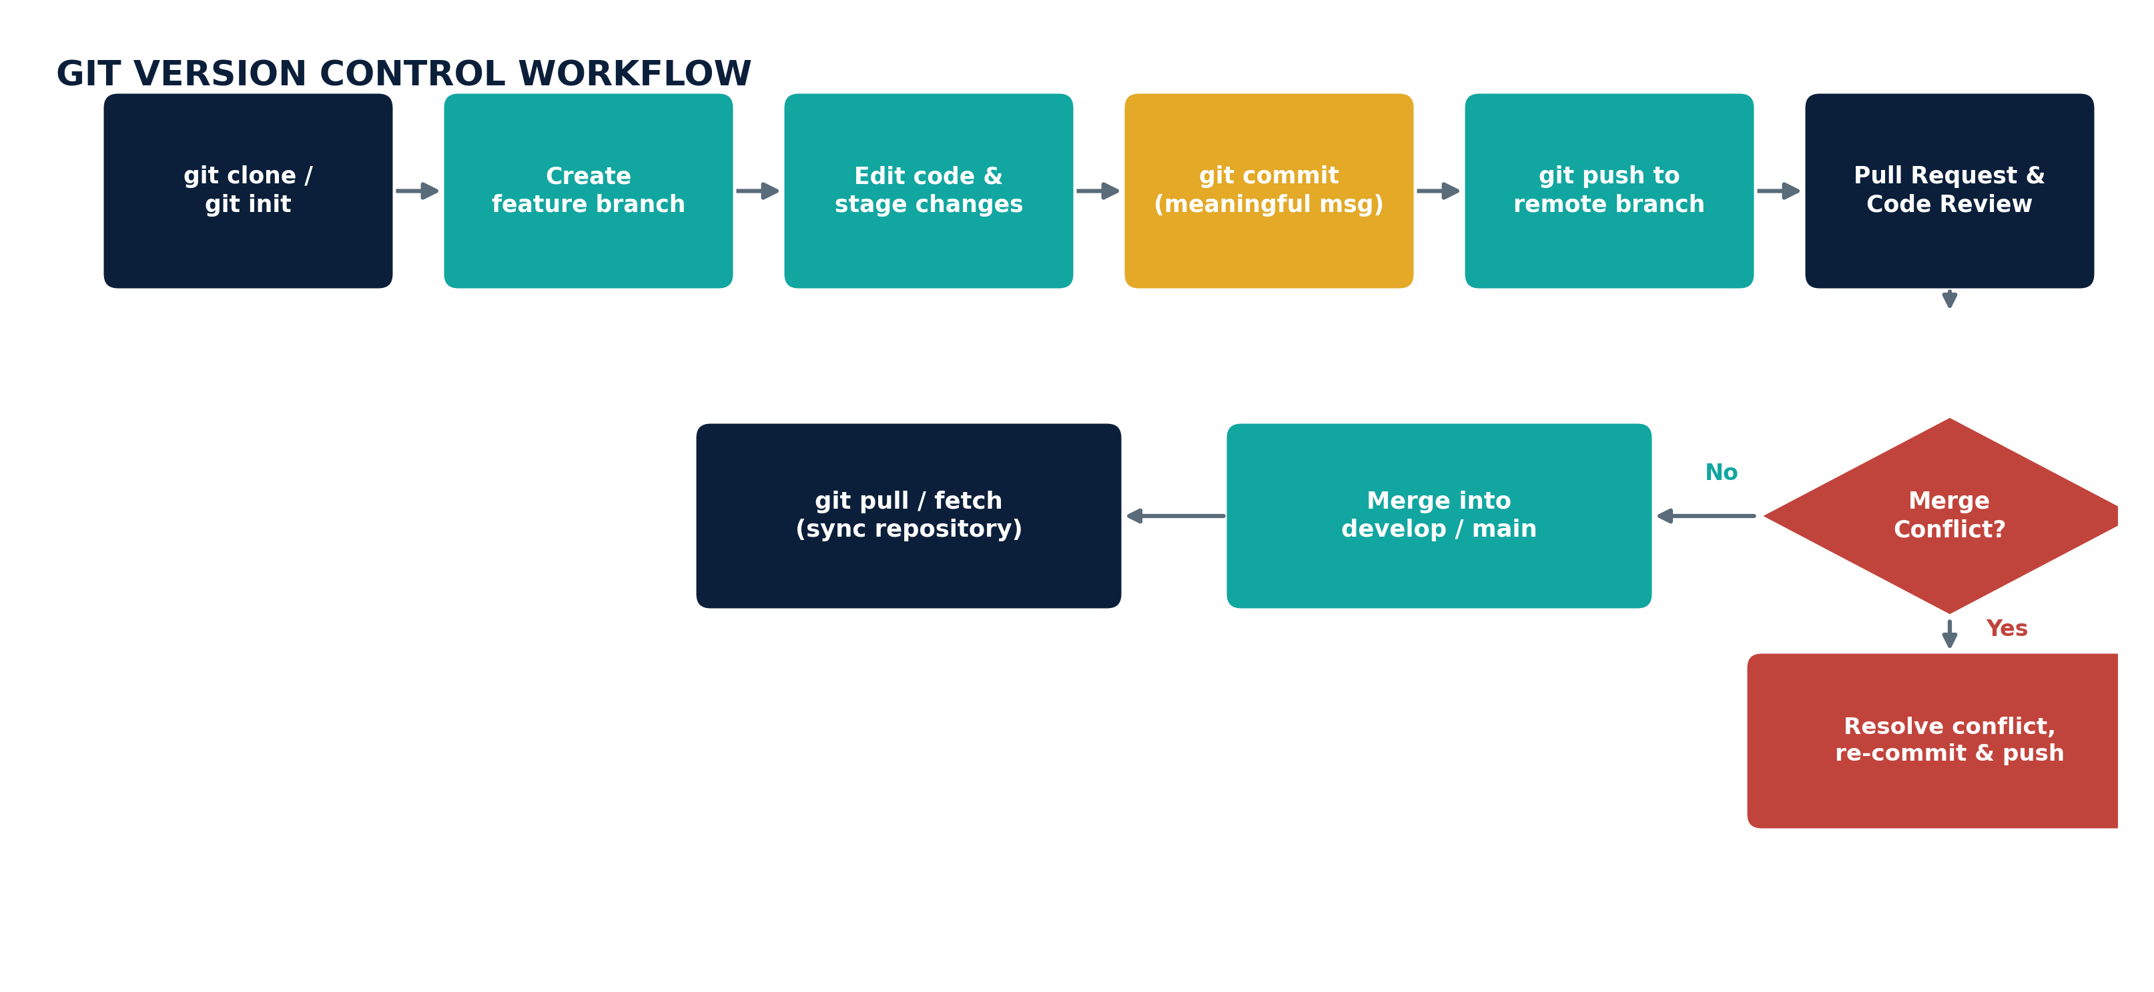
Figure 5.1 — End-to-end Git workflow followed for every change
Demonstrated Workflow (AI/ML Service Example)
$ git checkout develop && git pull origin develop
$ git checkout -b feature/failure-prediction-model
... edit predict.py, train.py ...
$ git add ai-ml-service/
$ git commit -m "feat(ai-ml): add LSTM failure-prediction model"
$ git push origin feature/failure-prediction-model
# Pull Request opened: feature/failure-prediction-model -> develop
# Reviewer requests changes -> additional commits pushed to the same branch
$ git checkout develop
$ git merge feature/failure-prediction-model
Auto-merging ai-ml-service/predict.py
CONFLICT (content): Merge conflict in ai-ml-service/predict.py
... conflict markers resolved manually, model threshold value kept from develop ...
$ git add ai-ml-service/predict.py
$ git commit -m "merge: resolve conflict - keep latest threshold config"
$ git push origin develop
Purpose of Each Git Operation
Operation | Purpose
git checkout -b | Creates and switches to an isolated feature branch, protecting develop from unfinished work.
git add / commit | Stages and records a meaningful snapshot of the change with a descriptive message.
git push | Publishes local commits to the remote repository so others (and CI) can see the work.
Pull Request review | Adds a human quality gate before code reaches a shared branch.
git merge | Integrates the reviewed feature into develop, combining both histories.
Conflict resolution | Manually reconciles two changes to the same lines so no work is silently lost.
git pull / fetch | Synchronises the local repository with the latest remote history before new work begins.

6. Commit History Analysis
A sample of the commit history for the ai-ml-service branch, viewed with git log --oneline, illustrates the convention followed across the project.
$ git log --oneline --graph -8
* 9c4e21a (HEAD -> develop) merge: resolve conflict - keep latest threshold config
* 6a18f3d feat(ai-ml): add LSTM failure-prediction model
* 2f0b9ce test(ai-ml): add unit tests for predict() edge cases
* d871a02 fix(edge-gateway): handle null humidity readings gracefully
* 77e4c56 docs(readme): document environment variables
* 1b93aa1 feat(backend-api): add /shipments/:id/alerts endpoint
* 4e10cd3 refactor(dashboard): extract MapView into its own component
* 0a5d8e9 chore: initial commit - project scaffolding
Commit Types Used
Prefix | Meaning | Example
feat | A new feature or capability | feat(ai-ml): add LSTM failure-prediction model
fix | A bug fix | fix(edge-gateway): handle null humidity readings gracefully
docs | Documentation-only change | docs(readme): document environment variables
test | Adds or updates tests | test(ai-ml): add unit tests for predict() edge cases
refactor | Code restructuring with no behaviour change | refactor(dashboard): extract MapView component
chore | Tooling, scaffolding or maintenance work | chore: initial commit - project scaffolding
Following the Conventional Commits style keeps the history searchable and self-documenting: a reviewer can tell what changed and why without opening the diff, and tools can auto-generate changelogs by grouping commits by prefix. Short, present-tense, scoped messages (service in parentheses) make git log and git blame genuinely useful for future maintenance.

7. Docker Environment Design
The platform is made up of several services written in different languages (Python for the AI/ML engine, Node.js for the backend API, a JavaScript dashboard) with different runtime dependencies. Docker is well suited here because it packages each service together with its exact dependencies into a portable image, so the model that a data scientist trained locally behaves identically on a teammate's laptop, in CI, and in production — removing the classic “it works on my machine” failure mode. Containers also isolate services from one another, so a memory leak in the AI/ML engine cannot take down the dashboard.
Components Identified for Containerization
Component | Why It Needs Containerization
Edge Gateway | Runs on varied edge/field hardware; a container guarantees identical behaviour everywhere it is deployed.
AI/ML Service | Depends on specific versions of TensorFlow/PyTorch that must not clash with other services.
Backend API | Needs a consistent Node.js runtime and network configuration across dev, staging and production.
Dashboard Frontend | Built once and served identically regardless of the host operating system.
PostgreSQL Database | Runs as an official pre-built image with a persistent volume, avoiding manual DB installation.
MQTT Broker / Redis Cache | Lightweight infrastructure services best run as disposable, versioned containers.

8. Dockerfile Development
The Dockerfile below containerizes the AI/ML prediction service. Each instruction is chosen to keep the resulting image small, reproducible and secure.
# ai-ml-service/Dockerfile
FROM python:3.11-slim AS base

WORKDIR /app

COPY requirements.txt .
RUN pip install --no-cache-dir -r requirements.txt

COPY . .

ENV MODEL_PATH=/app/models/failure_predictor.pkl
ENV PORT=6000

EXPOSE 6000

HEALTHCHECK --interval=30s --timeout=5s CMD curl -f http://localhost:6000/health || exit 1

CMD ["python", "predict.py"]
Purpose of Each Instruction
Instruction | Purpose
FROM python:3.11-slim | Starts from a minimal official Python base image to keep the image small and reduce attack surface.
WORKDIR /app | Sets the working directory inside the container for all subsequent instructions.
COPY requirements.txt . | Copies only the dependency list first so Docker can cache this layer between builds.
RUN pip install | Installs dependencies inside the image, baked in rather than installed at runtime.
COPY . . | Copies the remaining application source code into the image.
ENV | Sets configuration such as the model path and port as environment variables.
EXPOSE 6000 | Documents the port the service listens on for other containers and orchestration tools.
HEALTHCHECK | Lets Docker (and Compose) automatically detect and report an unhealthy container.
CMD | Defines the default command that runs when the container starts.

9. Docker Compose Design
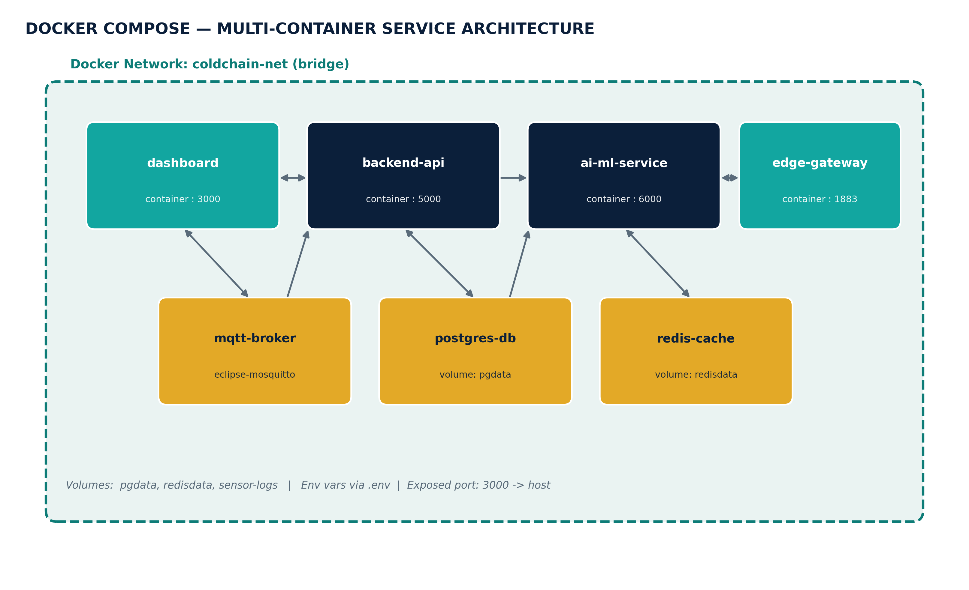
Figure 9.1 — Multi-container service architecture defined by docker-compose.yml
# docker-compose.yml
version: "3.9"
services:
dashboard:
build: ./dashboard-frontend
ports: ["3000:3000"]
depends_on: [backend-api]
networks: [coldchain-net]

backend-api:
build: ./backend-api
env_file: .env
depends_on: [postgres-db, mqtt-broker]
networks: [coldchain-net]

ai-ml-service:
build: ./ai-ml-service
depends_on: [redis-cache]
networks: [coldchain-net]

postgres-db:
image: postgres:16
environment:
POSTGRES_DB: coldchain
volumes: ["pgdata:/var/lib/postgresql/data"]
networks: [coldchain-net]

redis-cache:
image: redis:7
volumes: ["redisdata:/data"]
networks: [coldchain-net]

mqtt-broker:
image: eclipse-mosquitto:2
networks: [coldchain-net]

volumes: { pgdata: {}, redisdata: {} }
networks: { coldchain-net: { driver: bridge } }
Services, Networking, Volumes and Environment Variables
Element | Explanation
Services | Each block (dashboard, backend-api, ai-ml-service, etc.) maps one container to one responsibility, built either from a local Dockerfile or a trusted public image.
Networking | All services join the coldchain-net bridge network, so they can reach each other by service name (e.g. backend-api talks to postgres-db) without exposing internal ports to the host.
Volumes | pgdata and redisdata are named volumes that persist database and cache state across container restarts and rebuilds.
Environment Variables | backend-api loads secrets and configuration from a local .env file (never committed), keeping credentials out of the image and source code.
Dependencies | depends_on ensures, for example, that postgres-db and mqtt-broker are started before backend-api attempts to connect to them.

10. Container Deployment and Testing
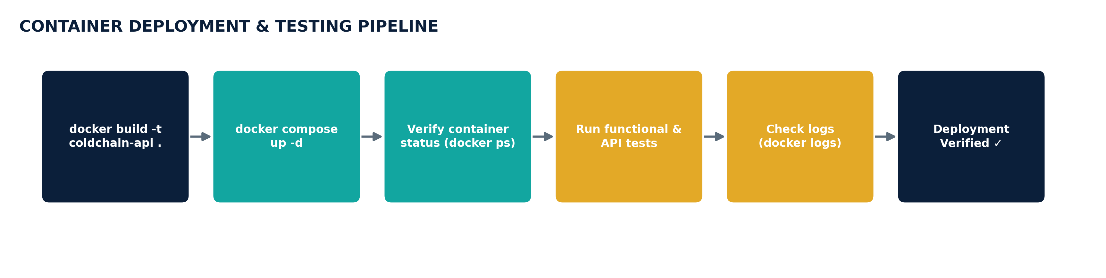
Figure 10.1 — Deployment and testing pipeline
$ docker compose build
$ docker compose up -d
[+] Running 6/6
✔ Container coldchain-postgres-db-1 Started
✔ Container coldchain-mqtt-broker-1 Started
✔ Container coldchain-redis-cache-1 Started
✔ Container coldchain-backend-api-1 Started
✔ Container coldchain-ai-ml-service-1 Started
✔ Container coldchain-dashboard-1 Started

$ docker ps --format "table {{.Names}}\t{{.Status}}\t{{.Ports}}"
NAMES STATUS PORTS
coldchain-dashboard-1 Up 12 seconds 0.0.0.0:3000->3000/tcp
coldchain-backend-api-1 Up 12 seconds (healthy) 0.0.0.0:5000->5000/tcp
coldchain-ai-ml-service-1 Up 12 seconds (healthy) 0.0.0.0:6000->6000/tcp
coldchain-postgres-db-1 Up 13 seconds 5432/tcp

$ curl http://localhost:5000/api/shipments/health
{"status":"ok","service":"backend-api","uptime":"12s"}
Testing was carried out in two layers: automated functional tests (unit tests for the prediction model, integration tests for the API endpoints) run inside the CI pipeline before the image is built, and a manual smoke test after docker compose up -d that hits each service's /health endpoint and confirms the dashboard renders live sensor data. The healthy status and successful curl response above confirm the containers started correctly and can talk to one another over the coldchain-net network.

11. Benefits of Git and Docker
Benefit | How Git Contributes | How Docker Contributes
Collaboration | Branches let multiple contributors work in parallel without overwriting each other's code. | Every teammate runs the identical stack locally, eliminating environment-related miscommunication.
Version Management | Full history, tags and diffs make it possible to trace exactly what changed and when. | Image tags (e.g. ai-ml-service:1.2.0) version the running environment alongside the code.
Portability | A cloned repository carries the entire project history to any machine. | A built image runs identically on a laptop, a CI runner, or a cloud VM.
Deployment Speed | Merged, reviewed code on main is always release-ready. | docker compose up brings the whole stack online in one command.
Scalability | Feature branches let the team scale development effort across many contributors. | Stateless containers can be replicated horizontally behind a load balancer.
Maintainability | Commit history and blame make root-causing regressions straightforward. | Isolated containers mean a fix to one service cannot silently break another.

12. Challenges and Improvements
Challenge Encountered | Suggested Improvement
Merge conflicts in the shared predict.py file when two contributors changed model thresholds simultaneously. | Split configuration values into a separate config.yaml so code and tunable parameters rarely collide.
Large AI/ML Docker image (trained model weights bundled in) slowed down builds and pushes. | Store model weights in an external artifact registry and mount them as a volume at runtime instead of baking them into the image.
Inconsistent .env values between teammates caused backend-api to fail on first run. | Provide a documented .env.example and validate required variables on container startup.
Services occasionally started in the wrong order despite depends_on. | Add explicit HEALTHCHECK directives so dependent services wait for a true “ready” state, not just container start.
Long-lived feature branches drifted far from develop, causing painful merges. | Encourage smaller, short-lived feature branches with frequent rebases against develop.
Looking ahead, the team plans to add automated CI checks that build every Docker image and run the full test suite on each pull request, adopt semantic version tags for release images, and introduce a staging environment that mirrors production before any hotfix reaches main.

